UNIT 6

SPEAKING STRATEGIES

Remember instructions for Speaking Part II “Task Cards” and a business in your country.
Use collocations, idioms, and phrasal verbs for your answer. Speak at least 2 minutes.

Describe a business in your country.
You should say:
- Do most people in your country work for small or large businesses?
-What do you think can be considered as emerging industries and why?
-What kind of small businesses are most popular?
-What should be the government’s role in how small businesses are run?
-How can businesses benefit the community in which they are located?

READING STRATEGIES

SUMMARY COMPLETION QUESTION

Task: completing a summary by filling in the gaps using words from the text or words given in a box.
Skills:
• scanning for specific information in the text
• understanding ideas and supporting points
• selecting appropriate words
Tips:
• identify the type of word needed for each gap (noun/verb/adjective etc)
• locate the information in the text in order to choose the write word
• if you choose words from the text, check how many words can be used for each answer
• answersusually comes in order
• the summary must be grammatically correct which can help you in choosing the right word for the gap

1 Read the passage below and answer questions.

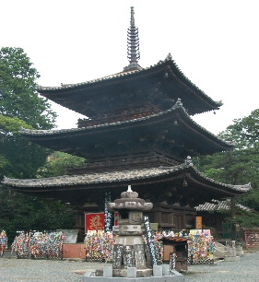 |  | WHY PAGODAS  DON’T  FALL DOWN

A In a land swept by typhoons and shaken by earthquakes, how have Japan's tallest and seemingly flimsiest old buildings - 500 or so wooden pagodas - remained standing for centuries? Records show that only two have collapsed during the past 1400 years. Those that have disappeared were destroyed by fire as a result of lightning or civil war. The disastrous Hanshin earthquake in 1995 killed 6,400 people, toppled elevated highways, flattened office blocks and devastated the port area of Kobe. Yet it left the magnificent five-storey pagoda at the Toji temple in nearby Kyoto unscathed, though it levelled a number of buildings in the neighbourhood.
B Japanese scholars have been mystified for ages about why these tall, slender buildings are so stable. It was only thirty years ago that the building industry felt confident enough to erect office blocks of steel and reinforced concrete that had more than a dozen floors. With its special shock absorbers to dampen the effect of sudden sideways movements from an earthquake, the thirty-six-storey Kasumigaseki building in central Tokyo - Japan's first skyscraper - was considered a masterpiece of modern engineering when it was built in 1968.
C Yet in 826, with only pegs and wedges to keep his wooden structure upright, the master builder Kobodaishi had no hesitation in sending his majestic Toji pagoda soaring fifty-five metres into the sky - nearly half as high as the Kasumigaseki skyscraper built some eleven centuries later. Clearly, Japanese carpenters of the day knew a few tricks about allowing a building to sway and settle itself rather than fight nature's forces. But what sort of tricks?
D The multi-storey pagoda came to Japan from China in the sixth century. As in China, they were first introduced with Buddhism and were attached to important temples. The Chinese built their pagodas in brick or stone, with inner staircases, and used them in later centuries mainly as watchtowers. When the pagoda reached Japan, however, its architecture was freely adapted to local conditions - they were built less high, typically five rather than nine storeys, made mainly of wood and the staircase was dispensed with because the Japanese pagoda did not have any practical use, but became more of an art object. Because of the typhoons that batter Japan in the summer, Japanese builders learned to extend the eaves of buildings further beyond the walls. This prevents rainwater gushing down the walls. Pagodas in China and Korea have nothing like the overhang that is found on pagodas in Japan.
E The roof of a Japanese temple building can be made to overhang the sides of the structure by fifty per cent or more of the building's overall width. For the same reason, the builders of Japanese pagodas seem to have further increased their weight by choosing to cover these extended eaves not with the porcelain tiles of many Chinese pagodas but with much heavier earthenware tiles.
F But this does not totally explain the great resilience of Japanese pagodas. Is the answer that, like a tall pine tree, the Japanese pagoda - with its massive trunk-like central pillar known as shinbashira - simply flexes and sways during a typhoon or earthquake? For centuries, many thought so. But the answer is not so simple because the startling thing is that the shinbashira actually carries no load at all. In fact, in some pagoda designs, it does not even rest on the ground, but is suspended from the top of the pagoda - hanging loosely down through the middle of the building. The weight of the building is supported entirely by twelve outer and four inner columns.
G And what is the role of the shinbashira, the central pillar? The best way to understand the shinbashira's role is to watch a video made by Shuzo Ishida, a structural engineer at Kyoto Institute of Technology. Mr Ishida, known to his students as 'Professor Pagoda' because of his passion to understand the pagoda, has built a series of models and tested them on a 'shake-table' in his laboratory. In short, the shinbashira was acting like an enormous stationary pendulum. The ancient craftsmen, apparently without the assistance of very advanced mathematics, seemed to grasp the principles that were, more than a thousand years later, applied in the construction of Japan's first skyscraper. What those early craftsmen had found by trial and error was that under pressure a pagoda's loose stack of floors could be made to slither to and fro independent of one another. Viewed from the side, the pagoda seemed to be doing a snake dance - with each consecutive floor moving in the opposite direction to its neighbours above and below. The shinbashira, running up through a hole in the centre of the building, constrained individual storeys from moving too far because, after moving a certain distance, they banged into it, transmitting energy away along the column.
H Another strange feature of the Japanese pagoda is that, because the building tapers, with each successive floor plan being smaller than the one below, none of the vertical pillars that carry the weight of the building is connected to its corresponding pillar above. In other words, a five- storey pagoda contains not even one pillar that travels right up through the building to carry the structural loads from the top to the bottom. More surprising is the fact that the individual storeys of a Japanese pagoda, unlike their counterparts elsewhere, are not actually connected to each other. They are simply stacked one on top of another like a pile of hats. Interestingly, such a design would not be permitted under current Japanese building regulations.
I And the extra-wide eaves? Think of them as a tightrope walker's balancing pole. The bigger the mass at each end of the pole, the easier it is for the tightrope walker to maintain his or her balance. The same holds true for a pagoda. 'With the eaves extending out on all sides like balancing poles,' says Mr Ishida, 'the building responds to even the most powerful jolt of an earthquake with a graceful swaying, never an abrupt shaking.' Here again, Japanese master builders of a thousand years ago anticipated concepts of modern structural engineering.
_________________________________
Cambridge IELTS 7 Examination Papers from university of Cambridge ESOL examinations: English for speakers of other languages – Cambridge University Press, 2009.

2 Do the following statements agree with the information given in the text?

YES if the statement agrees with the claims of the writer
NO if the statement contradicts with the claims of the writer
NOT GIVEN if it impossible to say what the writer thinks about this

1 Only two Japanese pagodas have collapsed in 1400 years.
2 The Hanshin earthquake of 1995 destroyed the pagoda at the Toji temple.
3 The other buildings near the Toji pagoda had been built in the last 30 years.
4 Pagodas in China were made of wood and used as art objects when in Japan
they were built in brick or stone and used mainly as watchtowers.
5 The builders of pagodas knew how to absorb some of the power produced by severe weather conditions.

3 Write the correct letter A, В or C. Classify the following as typical of

A both Chinese and Japanese pagodas
В only Chinese pagodas
С only Japanese pagodas

1 easy interior access to top
2 tiles on eaves
3 use as observation post
4 size of eaves up to half the width of the building
5 original religious purpose
6 floors fitting loosely over each other

4 Choose the correct letter, A, B, C or D.

1 A padoga in Japan
- is higher than in China and made of wood and used as watchtowers
- is less high than in China and made of wood as an art object
- is higher than in China and made of wood and used as watchtowers
- is less high than in China and made of stone as an art object

2 The Japanese pagodas have extended eaves mainly to
- prevent it from the rain
- extend structure
- make building much heavier
- make temple more stable

3 In a Japanese pagoda, the shinbashira
A bears the full weight of the building.
В bends under pressure like a tree.
С connects the floors with the foundations.
D stops the floors moving too far.

4 Shuzo Ishida performs experiments in order to
A improve skyscraper design.
В be able to build new pagodas.
С learn about the dynamics of pagodas.
D understand ancient mathematics.

5 The storeys of a Japanese pagoda are
A linked only by wood.
В fastened only to the central pillar.
С fitted loosely on top of each other.
D joined by special weights.

5 Complete the summary below. Choose no more than three words from the text for each answer.
A masterpiece of modern engineering in Japan is considered the thirty-six-storey 1 ____________ built in 1968. However, in 826 2_____________, the wooden structure fifty-five metres high, was built. 3 _____________ were the main tricks about building stable multi-storey padogas known for Japanese carpenters of the sixth century. 4 ______________ was the central pillar in a padoga which acted like an enormous stationary pendulum to stand the earthquake and was used in the construction of Japan's first skyscraper..

WRITING STRATEGIES

PIE CHART

• Pie charts can be like bar charts except that various sections add up to 100%. There can also be a series of charts where the data show trends.
• Show that you are looking at the pie chart: From the pie chart, it is clear/obvious/
evident that ...
• You can compare/contrast items: ... while ...; in contrast, ...
• See video to get more information https://www.youtube.com/watch?v=cTWXaLX2L6Y

The pie charts below show units of electricity production of fuel source in Australia and France in 1980 and 2000.
Summarize the information by selecting and reporting the main features, and making comparison where relevant.
Write at least 150 words. You should spend about 20 minutes on this task.

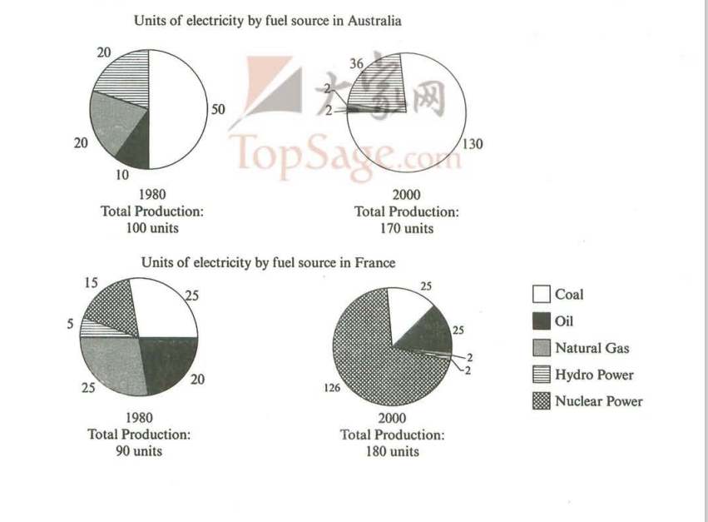

Горковенко А. 19-МТ-1 (АЯСЦ)

The pie charts illustrate how many units of electricity were produced from different fuel sources in Australia and France in the years 1980 and 2000.

As for electricity generation in Australia coal produced 50 units in 1980 and this figure rose substantially to 130 in 2000. Units of electricity produced from hydropower increased from 20 units in 1980 to 36 units twenty years later. By contrast, there was a considerable drop in the amount of electricity generated from natural gas and oil over the period given.

In France, units generated from coal and natural gas remained the same in both years 25 units each. However, nuclear power generated the most units of electricity in 2000. While only 15 units of electricity were produced from nuclear power in 1980, this amount rose to 126 units in 2000.

Overall, by 2000 these two countries relied on different principle fuel sources where Australia relied on Coal and France on nuclear power.
(156 words)

